P

Procedure & Subject Matter Protocol
Table of Contents
1. Introduction 4
2. Connection Mode 4
3. Link Test Message 4
4. Procedures of Data transaction 5
5. Message Format 5
6. Message List 8
7. Message Detail 11
8. Normal Process Scenario 25
9. Abnormal Process Scenario 29

Date | Reason/History | Revision | By whom | Signature
2019/11/12 | Create | 1.0 | David Ma
2019/11/18 | SOH Report added in S82 | 1.1 | David Ma
2021/05/13 | Move Change added in P85 | 1.2 | David Ma
2021/05/21 | 修正 S82 錯誤 | 1.3 | David Ma
2021/06/30 | P61新增2+4、6碼AlarmCode | 1.4 | David Ma
2021/09/02 | P25更新四槽位欄位 | 1.5 | David Ma
2021/09/06 | 修正 P43 錯誤 | 1.6 | David Ma
2021/09/11 | 新增P87、S88移除P19、修正P17、S18、S82 | 1.7 | David Ma
2022/03/03 | 新增P89、S90 | 1.8 | David Ma
2022/05/17 | 修改PS Protocol P65 | 1.9 | David Ma
2022/07/15 | 新增Map Change、ABCS Control | 2.0 | David Ma
2022/08/24 | 修改Map Change PS Protocol P31 | 2.1 | David Ma
2022/11/03 | 移除 PS Protocol P67，修改P89、S90敘述 | 2.2 | David Ma
2023/12/19 | 新增PS Protocol P51 Reach and  Stop | 2.3 | David Ma
2023/05/23 | 新增PS Protocol P61  2: reset warning  3: set warning | 2.4 | David Ma
2023/05/26 | 新版P45指令 | 2.5 | David Ma
2023/07/20 | 修改PS Protocol P27 | 2.6 | David Ma
2024/01/03 | 修改P25指令 | 3.0 | Mason Lin
2024/09/20 | 新增P19指令 4.1 |  | Jason Chi
2024/10/23 | 新增P39指令，修改P45指令 5.0 |  | Mike Lin

Revision History

- 目的 Purpose：定義 TCP/IP上訊息傳遞的通訊控制介面。
- 適用範圍 Scope：這份規格文件是針對捷螺內部或與供應商之間，關於系統間透過TCP/IP傳遞訊息的通訊控制規範，適用範圍涵蓋：單機或複合型式的主製程設備、檢測設備(測試設備)、小型工具機及傳送設備等不同控制軟體間的通訊使用。
- 名詞定義 Terms Definition：無
- 作業流程與內容 Procedure & Subject Matter：
Notice:
- 此規範不是最終版本，可依機台特性修改。
This specification is not the final version and can be modified depend on the equipment characteristic.
- 機台廠商須給免費解決所有軟體 bug 於捷螺公司或客戶端。
The equipment provider has to deliver bug-free software to Gyro before it is tested at Gyro or customer site.
- 如果在測試期間有任何 bug,不論是否與規格相符或為軟體本身 bug，捷螺保留最後規格的決定權，且不須負任何費用給廠商。
If there is any bug during the testing stage, whether it is specification discrepancy or software bug, Gyro reserves the final right to perform the specification change without any charge by vendor.
- 於驗收測試後，廠商必須提供 3 年的保證服務。
After the acceptance test the vendor have to provide three-year warranty service.

- Introduction
PS Protocol is a simple protocol using at communication via TCP/IP. It’s similar to HSMS + SECS II standard but easy to implement. It directly uses string transferring to byte array than send out to the other side.
- Connection Mode
Active Side: TCP Client
Passive side: TCP Server
- Link Test Message
P00: Link Test Request
S00: Link Test Reply
Both Active/Passive side can send P00 to the other side and receiver must reply S00 immediately. The side who send P00 need to check T6 timeout.
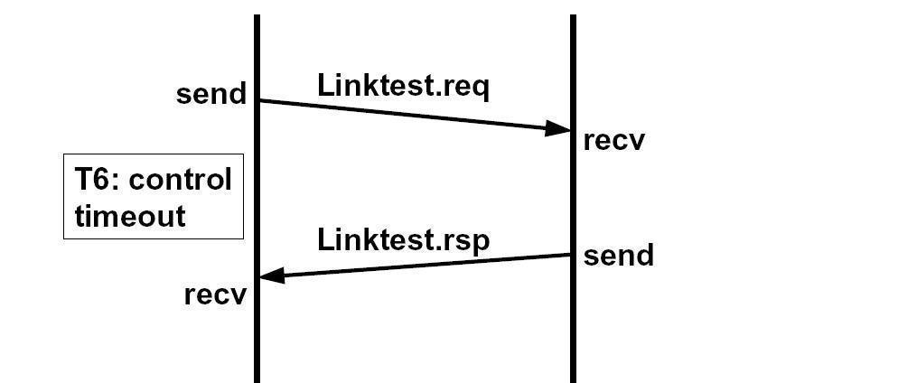
- Procedures of Data transaction
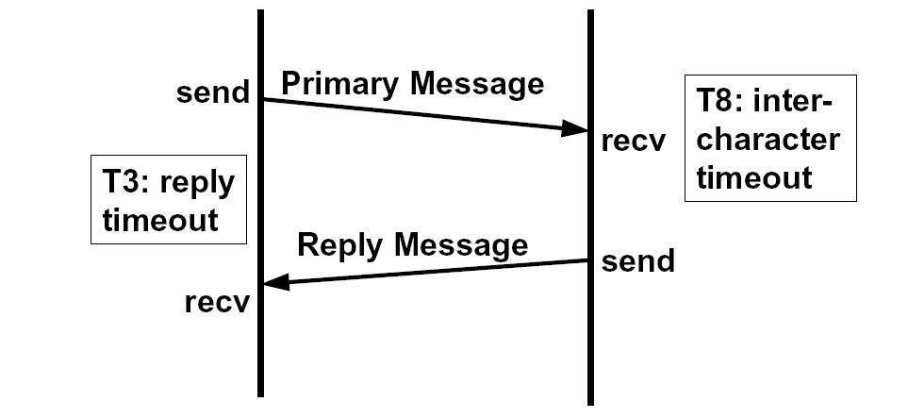
- Message Format
The message format composes message length, header, data and checksum. Size of message length is 1 byte, header is 3 bytes, system bytes are 4 bytes, and data is other bytes.
Block — header plus up to 125 bytes of data.
Message Lengths — The unsigned integer value of the first byte sent after receipt of EOT is the length of the block being sent. The length includes the bytes sent after the length byte, excluding the 2 bytes of the checksum. The maximum block length allowed by message is 224 bytes, and the minimum is 3 bytes.
System Bytes — The system bytes is unique. The system bytes of secondary message is copy from primary message.
Header —The operation of all communications functions above the message transfer protocol is linked to information contained in a 3-byte data element called the header. The header is always the first 3 bytes of every block sent by the message transfer protocol.
Primary Message (hereinafter called as “P”)— A primary message is defined as any odd numbered message.
Secondary Message (hereinafter called as “S”) — A secondary message is defined as any even numbered message.
The header and data information type is character of ASCII, message length and system bytes are Hex of ASCII (see Figure 4).
Reply Timeout, T3 — The reply timeout, T3, limits the time between sending primary message and receiving secondary message.
Link Test Reply Timeout, T6 — The link test reply timeout, T6, limits the time between sending P00 and receiving S00.
Message length_{s} 7 6 5 4 3 2 1 0
04 | 0 | 0 | 0 | 0 | 0 | 1 | 0 | 0
Header
P | 0 | 1 | 0 | 1 | 0 | 0 | 0 | 0
2 | 0 | 0 | 1 | 1 | 0 | 0 | 1 | 0
1 | 0 | 0 | 1 | 1 | 0 | 0 | 0 | 1
Data
3 | 0 | 0 | 1 | 1 | 0 | 0 | 1 | 1
0 | 0 | 0 | 1 | 1 | 0 | 0 | 0 | 0
9 | 0 | 0 | 1 | 1 | 1 | 0 | 0 | 1
0 | 0 | 0 | 1 | 1 | 0 | 0 | 0 | 0
System Bytes
02 | 0 | 0 | 0 | 0 | 0 | 0 | 1 | 0
02 | 0 | 0 | 0 | 0 | 0 | 0 | 1 | 0
02 | 0 | 0 | 0 | 0 | 0 | 0 | 1 | 0
17 | 0 | 0 | 0 | 1 | 0 | 0 | 0 | 1
Primary Message Sample
Message length_{s} 7 6 5 4 3 2 1 0
00 | 0 | 0 | 0 | 0 | 0 | 0 | 0 | 0
Header
S | 0 | 1 | 0 | 1 | 0 | 0 | 1 | 1
2 | 0 | 0 | 1 | 1 | 0 | 1 | 0 | 0
2 | 0 | 0 | 1 | 1 | 0 | 1 | 0 | 0
Data
System Bytes
02 | 0 | 0 | 0 | 0 | 0 | 0 | 1 | 0
02 | 0 | 0 | 0 | 0 | 0 | 0 | 1 | 0
02 | 0 | 0 | 0 | 0 | 0 | 0 | 1 | 0
17 | 0 | 0 | 0 | 1 | 0 | 0 | 0 | 1
Secondary Message Sample
- Message List
Message  Classification | Message  ID | Message  Direction | Description
ON-Line/  OFF-Line  Request | P11 | TSC 🡸Loc | Try Auto Request
ON-Line/  OFF-Line  Request | S12 | TSC 🡺Loc | Try Auto Request Ack.
ON-Line/  OFF-Line  Request | P13 | TSC 🡸Loc | Set Manual Request
ON-Line/  OFF-Line  Request | S14 | TSC 🡺Loc | Set Manual Request Ack.
ON-Line/  OFF-Line  Request | P15 | TSC 🡺Loc | Date and Time Setting
ON-Line/  OFF-Line  Request | S16 | TSC 🡸Loc | Date and Time Setting Ack.
ON-Line/  OFF-Line  Request | P17 | TSC🡸🡺Loc | Version Info Request
ON-Line/  OFF-Line  Request | S18 | TSC🡸🡺Loc | Version Info Request Ack.
ON-Line/  OFF-Line  Request | S20 | TSC 🡸Loc | WIFI Signal Strength Info Ack.
ON-Line/  OFF-Line  Request | P21 | TSC 🡸Loc | Move Status Report
Passive and Active  Status Report | S22 | TSC 🡺Loc | Move Status Report Ack.
Passive and Active  Status Report | P23 | TSC 🡸Loc | Robot Status Report
Passive and Active  Status Report | S24 | TSC 🡺Loc | Robot Status Report Ack.
Passive and Active  Status Report | P25 | TSC 🡸Loc | Slot status report
Passive and Active  Status Report | S26 | TSC 🡺Loc | Slot status report Ack
Passive and Active  Status Report | P27 | TSC 🡸Loc | Cassette Status Rename Request
Passive and Active  Status Report | S28 | TSC 🡺Loc | Cassette Status Rename Request Ack.
Passive and Active  Status Report | P29 | TSC 🡸Loc | Charge Status Report
Passive and Active  Status Report | S30 | TSC 🡺Loc | Charge Status Report Ack.
Passive and Active  Status Report | P31 | TSC 🡺Loc | Status Report Request
Passive and Active  Status Report | S32 | TSC 🡸Loc | Status Report Request Ack.
Passive and Active  Status Report | P33 | TSC 🡺Loc | Position Report Request
Passive and Active  Status Report | S34 | TSC 🡸Loc | Position Report Request Ack.
Passive and Active  Status Report | P35 | TSC 🡺Loc | Battery Status Request
Passive and Active  Status Report | S36 | TSC 🡸Loc | Battery Status Request Ack.
Passive and Active  Status Report | P37 | TSC 🡺Loc | Command info report
Passive and Active  Status Report | S38 | TSC 🡸Loc | Command info report Ack
Passive and Active  Status Report | P39 | TSC 🡺Loc | Current command info report

Message  Classification | Message  ID | Message  Direction | Description
Command Request | P41 | TSC 🡺Loc | Move Command
Command Request | S42 | TSC 🡸Loc | Move Command Ack
Command Request | P43 | TSC 🡺Loc | Move Append Arrival Report
Command Request | S44 | TSC 🡸Loc | Move Append Arrival Report Ack.
Command Request | P45 | TSC 🡺Loc | Robot Command Request
Command Request | S46 | TSC 🡸Loc | Robot Command Request Ack.
Command Request | P47 | TSC 🡺Loc | Charge Request
Command Request | S48 | TSC 🡸Loc | Charge Request Ack.
Command Request | P49 | TSC 🡺Loc | Clear Robot Command Request
Command Request | S50 | TSC 🡸Loc | Clear Robot Command Request Ack.
Command Request | P51 | TSC 🡺Loc | Stop Request
Command Request | S52 | TSC 🡸Loc | Stop Request Ack.
Command Request | P53 | TSC 🡸Loc | Robot command result report
Command Request | S54 | TSC 🡸Loc | Robot command result report Ack
 | P81 | TSC 🡺Loc | AGV info request
 | S82 | TSC 🡸Loc | AGV info request Ack
 | P83 | TSC 🡺Loc | Robot Command
 | S84 | TSC 🡸Loc | RobotCommand Ack
 | P85 | TSC 🡺Loc | Move Change Request
 | S86 | TSC 🡸Loc | Move Change Request Ack
 | P87 | TSC 🡸Loc | Robot Command
 | S88 | TSC 🡸Loc | AGV info request Ack
 | P89 | TSC 🡺Loc | Erack Placement Signal
 | S90 | TSC 🡸Loc | Erack Placement Signal Ack.

Message  Classification | Message  ID | Message  Direction | Description
Alarm Set and Reset  Request | P61 | TSC🡸🡺Loc | Alarm Report
Alarm Set and Reset  Request | S62 | TSC🡸🡺Loc | Alarm Report Ack.
Alarm Set and Reset  Request | P63 | TSC🡸🡺Loc | Reset All Alarm Request
Alarm Set and Reset  Request | S64 | TSC🡸🡺Loc | Reset All Alarm Request Ack.
Alarm Set and Reset  Request | P65 | TSC 🡸Loc | Move Obstacles
Alarm Set and Reset  Request | S66 | TSC 🡺Loc | Move Obstacles Ack.

Message  Classification | Message  ID | Message  Direction | Description
MAP change | P91 | TSC🡺Loc | 回報目前地圖
MAP change | S92 | TSC🡸Loc | 回報目前地圖確認
MAP change | P93 | TSC🡺Loc | 更換地圖
MAP change | S94 | TSC🡸Loc | 更換地圖確認
MAP change | P95 | TSC 🡸Loc | 更換地圖狀態
MAP change | S96 | TSC 🡺Loc | 更換地圖狀態確認

Message  Classification | Message  ID | Message  Direction | Description
ABCS Control | P71 | TSC🡺Loc | 開始電池交換
ABCS Control | S72 | TSC🡸Loc | 回報狀態
ABCS Control | P73 | TSC🡺Loc | 交換成功、失敗
ABCS Control | S74 | TSC🡸Loc | 收到
ABCS Control | P75 | TSC 🡸Loc | 電池交換狀態
ABCS Control | S76 | TSC 🡺Loc | 收到

Message  Classification | Message  ID | Message  Direction | Description
Event Report | P19 | TSC 🡸Loc | 事件回報
Event Report | S20 | TSC 🡺Loc | 收到

- Message Detail
P00 | Contents: Link Test Request | Direction
P00 | Structure：Header only | TSC 🡸🡺 Loc
S00 | Contents: Link Test Request Ack. | Direction
S00 | Structure：Header only | TSC🡸🡺Loc
P11 | Contents: Try Auto Request | Direction
P11 | Structure：Header only | TSC 🡸Loc
S12 | Contents: Try Auto Request Ack. | Direction
S12 | Structure：Header only | TSC 🡺Loc
P13 | Contents: Set Manual Request | Direction
P13 | Structure：Header only | TSC 🡸Loc
S14 | Contents: Set Manual Request Ack. | Direction
S14 | Structure：Header only | TSC 🡺Loc
P15 | Contents: Date and Time Setting | Direction
P15 | Structure：14 Bytes  YYYYMMDDHHMMSS  E.g. Data = 20200304153152 | TSC 🡺Loc
P16 | Contents: Date and Time Setting Ack. | Direction
P16 | Structure：1 Bytes  0 = Date and Time Setting Accepted | TSC 🡸Loc

P17 | Contents: Version Info Request | Direction
P17 | Structure：Header only | TSC🡸🡺Loc
S18 | Contents: Version Info Request Ack. | Direction
S18 | Structure：22 Bytes  15 Byte : Sw + Software Version  7 Byte : Sp + Spec Version  E.g. Data = Sw2020.04.22.01Sp2.3 | TSC🡸🡺Loc
P19 | Contents: Event Report | Direction
P19 | Structure：1 Bytes  0 = Retry action | TSC🡸Loc
S20 | Contents: Event Report Ack. | Direction
S20 | Structure：Header only | TSC 🡺Loc

P21 | Contents: Move Status Report | Direction
P21 | Structure：4 Bytes  1 Byte = 0:Idle, 1:Working, 2:Pausing, 3:Pause,  4:Stoping, 5:Block, 6:Error  2~4 Byte = Head Direction (0 ~ 359)  E.g. AGVL want to update move state is Idle and head angle is 0. Data = 0000  E.g. AGVL want to update move state is Error and head angle is 90. Data = 6090 | TSC 🡸Loc
S22 | Contents: Move Status Report Ack. | Direction
S22 | Structure：Header only | TSC 🡺Loc
P23 | Contents: Robot Status Report | Direction
P23 | Structure：2 Bytes  - Byte = Status, 0:Idle, 1:Busy, 2:Error  - Byte = Home, 0:Not Home, 1:Home  E.g. AGVL want to update robot state is Idle and robot is home. Data = 01  E.g. AGVL want to update robot state is Error and robot is not home.  Data = 20 | TSC 🡸Loc
S24 | Contents: Robot Status Report Ack. | Direction
S24 | Structure：Header only | TSC 🡺Loc

P25 | Contents: Cassette Status Report | Direction
P25 | Structure：N Byte  2 Byte = AGV槽位編號，01、02、03、04、......10、11......  - Byte = 0:Empty, 1:Loading, 2: ReadIdFail ,3: PositionError  3~N Byte = Cassette ID / Empty / ReadIdFail / PositionError  範例:  AGVL第一槽位回報無Cassette Data = 010  AGVL 第二槽位回報Cassette ID (ABC) Data = 021ABC  AGVL 第三槽位回報讀取失敗 Data = 032ReadIdFail or 032  AGVL第四槽位回報放置位置異常(PS/PL Sensor狀態異常)  Data = 043PositionError | TSC 🡸Loc
S26 | Contents: Cassette Status Report Ack. | Direction
S26 | Structure：Header only | TSC 🡺Loc

P27 | Contents: Cassette Status Rename Request | Direction
P27 | Structure：N Bytes  2 Byte = Vehicle carrier slot number  3~N Byte = Cassette ID  E.g. TSC want to rename 01 slot cassette ID into “ABC”. Data = 01ABC  E.g. TSC want to rename 12 slot cassette ID into “Error”. Data = 12Error | TSC 🡺Loc
S28 | Contents: Cassette Status Rename Request Ack. | Direction
S28 | Structure：Header only | TSC 🡸Loc
P29 | Contents: Charge Status Report | Direction
P29 | Structure：1 Bytes  0 = Off, Coupler back to home 1 = On, Since PIO start  E.g. AGVL want to update battery is charging or has start charge PIO. Data = 1  E.g. AGVL want to update battery is not charging and has end charge PIO.  Data = 0 | TSC 🡸Loc
S30 | Contents: Charge Status Report Ack. | Direction
S30 | Structure：Header only | TSC 🡺Loc

P31 | Contents: Status Report Request | Direction
P31 | Structure：1 Bytes  - = All Status  - = Move Status  - = Robot Status  - = Cassette Status  - = Charge Status  - = 查詢地圖  E.g. TSC want to update all status. Data = 0  E.g. TSC want to update charge status. Data = 4 | TSC 🡺Loc
S32 | Contents: Status Report Request Ack. | Direction
S32 | Structure：Header only | TSC 🡸Loc

P33 | Contents: Position Report Request | Direction
P33 | Structure：Header only | TSC 🡺Loc
S34 | Contents: Position Report Request Ack. | Direction
S34 | Structure：29 Bytes  - Byte = 0:Idle, 1:Working, 2:Pausing, 3:Pause,  4:Stoping, 5:Stop, 6:Error  - Byte = Position X signature, P:Positive,N:Negitive  3~10 Byte = Position X,  11 Byte = Position Y signature, P:Positive,N:Negitive  12~19 Byte = Position Y  20~22 Byte = Head Direction (0 ~ 359)  23~25 Byte = Moving Direction (0 ~ 359)  26~29 Byte = Move Speed  E.g. AGVL want to update position is Idle at (12345678,-98765432) with head angle is 0 move direction and speed are 0. Data =  0P12345678N987654320000000000  E.g. AGVL want to update vehicle is move pass position  (12345678,-98765432) with head angle is 90 move direction is 0 and speed is  1500. Data = 1P12345678N987654320900001500 | TSC 🡸Loc

P35 | Contents: Battery Status Request | Direction
P35 | Structure：Header only | TSC 🡺Loc
S36 | Contents: Battery Status Request Ack. | Direction
S36 | Structure： 10 Byte  - Byte = Percentage  - Byte = Voltage  3 Byte = Temperature  E.g. AGVL want to update battery state with Percentage is 72 , Voltage is  54.23,and Temperature is 40, Data = 0725423040 | TSC 🡸Loc
P37 | Contents: Set Command Info | Direction
P37 | Structure：N Bytes  1 Byte : Command Step, 0 = Begin, 1 = End.  First <> : Command ID (Could be empty if end)  Second <> : From Port Name (Could be empty)  Third <> : To Port Name (Could be empty if end)  Fourth <> : Cassette ID (Could be empty)  Fifth <> : Lot ID (Could be empty)  E.g. TSC want to update AGVL begin a transfer command with Command ID is Cmd001, From Port Num is 10007, To Port Num is 10005, using Buffer1, Lot ID = 001, and CST ID is CST002.  P390<Cmd001><BUFFER1><10005><CST002><001> | TSC 🡺Loc
S38 | Contents: Set Command Info Ack. | Direction
S38 | Structure：1 Bytes  0 = NG, 1 = OK. | TSC 🡸Loc
P39 | Contents: Set Current Command Info | Direction
P39 | Structure：N Bytes  1 Byte : Command Step, 0 = Begin, 1 = End.  First <> : Command ID (Could be empty if end)  Second <> : From Port Name (Could be empty)  Third <> : To Port Name (Could be empty if end)  Fourth <> : Cassette ID (Could be empty)  Fifth <> : Lot ID (Could be empty)  E.g. TSC want to update AGVL begin a transfer command with Command ID is Cmd001, From Port Num is 10007, To Port Num is 10005, using Buffer1, Lot ID = 001, and CST ID is CST002.  P390<Cmd001><BUFFER1><10005><CST002><001> | TSC 🡺Loc
S40 | Contents: Set Current Command Info Ack. | Direction
S40 | Structure：1 Bytes  0 = NG, 1 = OK. | TSC 🡸Loc

P41 | Contents: Move Append Request | Direction
P41 | Structure：28 Bytes  1Byte: 0:無需退站進站，1:到站點後執行二次定位，2:在站點執行退站  2~10Byte: P(正)N(負)P00001234為上報Routemap X:1.234，若是N00001234 X:-1.234，取小數點三位  11~19Byte: P(正)N(負)P00001234為上報Routemap Y:5.678，若是N00001234 Y:-5.678，取小數點三位  20~22Byte: 車頭方向單位為度，通常為0、90、180、270度，注意不可有負數  23~26Byte: 速度限制:500 設定值/1000，500/1000=0.5 ，若當前最高車速為1m/s 1m/0.5 = 0.5m/s  27Byte: 選擇開啟AGV槽位 0 : 無，1 : 左開蓋，2 : 右開蓋，3 : 左右開蓋  28Byte = Keep 或 GO ，Keep時該命令不會執行，AGV只會執行GO  29Byte = 是否允許自由避障 0: 不可，1:可  30~NByte = 標示此為一段路徑中的第幾號。以"<"開頭，">"結尾。以idx/total表示此段路徑有total個點，此命令為第idx個。若收移動命令的過程中有跳號則會整筆命令拒絕。  範例:  TSC請求AGVL先退站並移動到(X:1.234,Y:5.678)並且到站時角度為90度，速度限制為500/1000=0.5，當前AGV最高速*0.5，且不開蓋、會執行該命令，此路段不開放自由避障，目前為第1筆，總共有20筆  命令 = 2P00001234P0000567809005000G0<1/20> | TSC 🡺Loc
S42 | Contents: Move Append Request Ack. | Direction
S42 | Structure：1 Bytes  0 = NG, 1 = OK.. | TSC 🡸Loc
P43 | Contents: Move Append Arrival Report | Direction
P43 | Structure：29 Bytes  - Byte = Is arrival or not, 0:Fail(Move Stop), 1:Arrival, 2:EndArrival  - Byte = Position X signature, P:Positive,N:Negitive  3~10 Byte = Position X,  11 Byte = Position Y signature, P:Positive,N:Negitive  12~19 Byte = Position Y  20~22 Byte = Head Direction  23~25 Byte = Moving Direction  26~29 Byte =Speed  29~N Byte = Station ID  E.g. AGVL arrive at (1234,-5678), arrival style is End, vehicle Head Angle at  (1234,-5678) is 90 degree, Moving Driection is 90 degree, arrival speed is 0 , Station ID is ABC.  Data = 2P00001234N000056780900900000ABC | TSC 🡸Loc

S44 | Contents: Move Append Arrival Report Ack. | Direction
S44 | Structure：Header only | TSC 🡺Loc
P45 | Contents: Robot Command Request | Direction
P45 | Structure：24 Bytes  <1st>: 0:無使用PIO(E84)，1:AGV左PIO(E84)，2:AGV右PIO(E84)，2:AGV前PIO(E84)  <2nd>: E84 CS訊號，數字0到30  <3rd>: 0-沒有後續交握，1-有後續交握  <4th>: Carrier Type，數字  <5th>:可為BUFFER(車上儲位)，或是station ID，手臂取貨點  <6th>: 取貨點Port Number，數字  <7th>:可為BUFFER(車上儲位)，或是station ID，手臂放貨點  <8th>: 放貨點Port Number，數字1  <9th>: Extra info，內容為json格式  範例:  命令: P45<0><0><0><1><BUFFER><1><pErack001_1><2><{}>  在pErack001_1這站，從BUFFER1上到port2，carrier為第1種，不需要E84交握，無額外資訊  命令: P45<1><0><1><2><pErack001_1><1><BUFFER><1><{"height": "10"}>  在pP001這站，從port1下到BUFFER1，用左邊的sensor以CS_0做交握，carrier為第2種，後續有其他手臂動作，高度為10  命令: P45<2><1><0><3><BUFFER><1><pP001><2><{}>  在pP001這站，從BUFFER1上到port2，用右邊的sensor以CS_1做交握，carrier為第3種，後續無其他手臂動作，無額外資訊 | TSC 🡺Loc
S46 | Contents: Robot Command Request Ack. | Direction
S46 | Structure：1 Byte  0 = OK, 1 = From Port is Empty, 2 = To Port is Full. | TSC 🡸Loc
P47 | Contents: Charge Request | Direction
P47 | Structure：1 Bytes  1 Byte = Direction, 0:DisCharge, 1:Left, 2:Right.  E.g. TSC request AGVL to Start charge with Right Side PIO. Data = 2  E.g. TSC request AGVL to Stop charge. Data = 0 | TSC 🡺Loc

S48 | Contents: Charge Request Ack. | Direction
S48 | Structure：Header only | TSC 🡸Loc
P49 | Contents: Clear Robot Command Request | Direction
P49 | Structure：Header only | TSC 🡺Loc
S50 | Contents: Clear Robot Command Request Ack. | Direction
S50 | Structure：1 Bytes  0 = NG, 1 = OK.. | TSC 🡸Loc
P51 | Contents: Stop Request | Direction
P51 | Structure：1 Bytes  0 = Pause, 1 = Resume 2 = Stop 3 = Reach and stop | TSC 🡺Loc
S52 | Contents: Stop Request Ack. | Direction
S52 | Structure：1 Bytes  0 = NG, 1 = OK. | TSC 🡸Loc
P53 | Contents: Robot Command Finished Report | Direction
P53 | Structure：15 Bytes  Finished = Robot Command Finished  InterlockError = Interlock Error  RobotError = Robot Error  E.g. AGVL want to report robot command is well done. Data = Finished  E.g. AGVL want to report robot command is fail at PIO before robot working.  Data = InterlockError | TSC 🡸Loc
S54 | Contents: Robot Command Finished Report Ack. | Direction
S54 | Structure：Header only | TSC 🡺Loc

P61 | Contents: Alarm Report | Direction
P61 | Structure：9 Bytes  First Byte = 0:復歸(對指定ErrorCode進行復歸), 1:設定(產生指定ErrorCode)  3:復歸(對指定WarningCode進行復歸),4:設定(產生指定WarningCode)  2~6 Byte = Error Code (2+4數字16進制)，或是(2英文+4數字16進制)  2~9 Byte = Error Code(K21)  範例AGVL 對TSC上報Alarm  2~3 Byte: 10:TM Robot原廠，11:Routemap，12:E84，13:TCP_Bridge，14:TM自定義，15:BS，16:Encoder，17:Canbus，18:RFID，19:槽位門，  20:AGV零件。  命令 :110123456  若是清除該Alarm  命令 : 010123456  範例: TSC 對AGVL下令Alarm 使用8碼AlarmCode  2~3 Byte: 00:TSC  命令 : 100654321  若是清除該Alarm  命令 : 000654321  範例AGVL 對TSC上報Alarm使用6碼或4+2碼AlarmCode  2~3 Byte TM or 10  命令: 1TM6543  1106543  詳細異常列表，請參閱異常列表排除 | TSC🡸🡺Loc
S62 | Contents: Alarm Report Ack. | Direction
S62 | Structure：Header only | TSC🡸🡺Loc
P63 | Contents: Reset All Alarm Request | Direction
P63 | Structure：Header only | TSC🡸🡺Loc
S64 | Contents: Reset All Alarm Request Ack. | Direction
S64 | Structure：Header only | TSC🡸🡺Loc
P65 | Contents: Move Obstacles | Direction
P65 | Structure：1 Bytes  0 = Off, 1 = On.  E.g. AGVL update obstacles info to TSC . Date = 1  E.g. AGVL detected obstacles info to TSC . Date = 0 | TSC 🡸Loc
S66 | Contents: Move Obstacles Ack | Direction
S66 | Structure：Header only | TSC 🡺Loc

P71 |  | Contents: 電池交換命令 | Direction
 |  | Structure：Header only | TSC🡺Loc
S72 |  | Contents: 電池交換命令確認 | Direction
 |  | Structure：  1 Byte = 0:NG, 1:OK | TSC🡸Loc
P73 |  | Contents: 電池交換結果 | Direction
 |  | Structure：  1 Byte = 0:交換完成, 1:交換失敗 | TSC🡸Loc
S74 | Contents: 電池交換結果確認 |  | Direction
S74 | Structure：Header only |  | TSC🡺Loc
P75 | Contents: 電池交換狀態 |  | Direction
P75 | Structure：  1 Byte = 0:不在交換1:交換中 |  | TSC🡸Loc
S76 | Contents: 電池交換狀態確認 |  | Direction
S76 | Structure：Header only |  | TSC🡺Loc

 | P81 |  | Contents: AGV info request |  | Direction
 |  |  | Structure：Header only |  | TSC🡺Loc
S82 |  | Contents: AGV info request Ack |  | Direction
 |  | Structure：  byte 1:  AGV moving status.  0: Idle  1: Moving  3: Paused  6: Error  byte 2:  Sign of AGV x coordinate.  P: Positive  N: Negative  byte 3~10:  AGV x coordinate (without sign) in milimeter.  byte 11:  Sign of AGV y coordinate.  P: Positive  N: Negative  byte 12~19:  AGV y coordinate (without sign) in milimeter.  byte 20~22:  AGV head angle in degrees(from 0 to 360).  byte 23~25:  AGV moving direction in degrees(from 0 to 360).  byte 26~29:  AGV moving speed in milimeter.  byte 30:  AGV robot status.  0: Idle  1: Busy  2: Error  byte 31:  AGV robot at home point or not.  0: Robot is not at home point  1: Robot is at home point  byte 32~34:  AGV battery SOC(from 0 to 100).  byte 35~38:  AGV battery voltage in V.  byte 39~41:  AGV battery temperature in Celsius.  byte 42~44:  AGV battery SOH(from 0 to 100).  byte 45:  AGV battery current  P: Positive  N: Negative  byte 46~50:  AGV battery current in mA |  | TSC 🡸Loc

 | P83 |  | Contents: Robot Command |  | Direction
 |  |  | Structure：  byte 1:  PIO direction.  0: None  1: Left  2: Right  byte 2~8:  From port. Can be either BUFFER1~BUFFER4 or port name  byte 9~15:  To port.Can be either BUFFER1~BUFFER4 or port name |  | TSC🡺Loc
S84 |  | Contents: AGV info request Ack |  | Direction
 |  | Structure：  byte 1:  AGV accepts or not.  0: Accept  1: From port is empty  2: To port is full |  | TSC🡺Loc
P85 |  | Contents: Move Change Request |  | Direction
 |  | Structure：28 Bytes  1Byte: 0:無需退站進站，1:到站點後執行二次定位，2:在站點執行退站  2~10Byte: P(正)N(負)P00001234為上報Routemap X:1.234，若是N00001234 X:-1.234，取小數點三位  11~19Byte: P(正)N(負)P00001234為上報Routemap Y:5.678，若是N00001234 Y:-5.678，取小數點三位  20~22Byte: 車頭方向單位為度，通常為0、90、180、270度，注意不可有負數  23~26Byte: 速度限制:500 設定值/1000，500/1000=0.5 ，若當前最高車速為1m/s 1m/0.5 = 0.5m/s  27Byte: 選擇開啟AGV槽位 0 : 無，1 : 左開蓋，2 : 右開蓋，3 : 左右開蓋  28Byte = Keep 或 GO ，Keep時該命令不會執行，AGV只會執行GO  範例:  TSC請求AGVL該站將停止(Go)點改為Keep點  命令 = 2P00001234P0000567809005000K |  | TSC 🡺Loc
S86 |  | Contents: Move Change Request Ack. |  | Direction
 |  | Structure：1 Bytes  0 = NG, 1 = OK.. |  | TSC 🡸Loc
P87 |  | Contents: Robot Command |  | Direction
 |  | Structure：  byte 1:  PIO direction.  0: None  1: Left  2: Right  <From Port>:不限長度  <To Port>:不限長度  byte 2~N  From port. Can be either BUFFER1~BUFFER4 or port name  Byte N:  To port.Can be either BUFFER1~BUFFER4 or port name |  | TSC 🡺Loc
S88 |  | Contents: AGV info request Ack |  | Direction
 |  | Structure：  byte 1:  AGV accepts or not.  0: Accept  1: From port is empty  2: To port is full |  | TSC 🡸Loc
P89 |  | Contents: Erack Placement Signal |  | Direction
 |  | Structure  byte 1:.  0: NG 代表可能手臂未把貨物放置好至貨架上，此命令會使手臂暫停，直到收到OK  1: OK手臂確實將貨物放置到貨架上，手臂可以回到初始位置 |  | TSC 🡺Loc
S90 |  | Contents: Erack Placement Signal Ack |  | Direction
 |  | Structure：Header only |  | TSC 🡸Loc

P91 |  | Contents: 回報目前地圖 | Direction
 |  | Structure：  1 ~ N Byte = 地圖名稱 | TSC🡸Loc
S92 |  | Contents: 回報目前地圖確認 | Direction
 |  | Structure：Header only | TSC🡺Loc
P93 |  | Contents: 更換地圖 | Direction
 |  | Structure：  1 ~ N Byte = 地圖名稱 | TSC🡺Loc
S94 | Contents: 更換地圖確認 |  | Direction
S94 | Structure：  1 Byte = 0:拒絕1:接受 |  | TSC🡸Loc
P95 | Contents: 更換地圖狀態 |  | Direction
P95 | Structure：  1 Byte = 0:失敗1:成功 |  | TSC🡸Loc
S96 | Contents: 更換地圖狀態確認 |  | Direction
S96 | Structure：Header only |  | TSC🡺Loc

- Normal Process Scenario
- Online
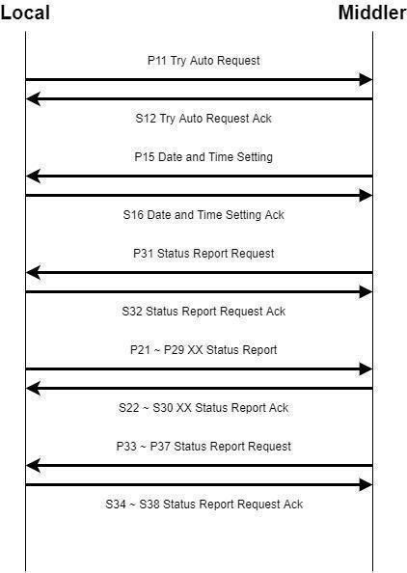

- Move
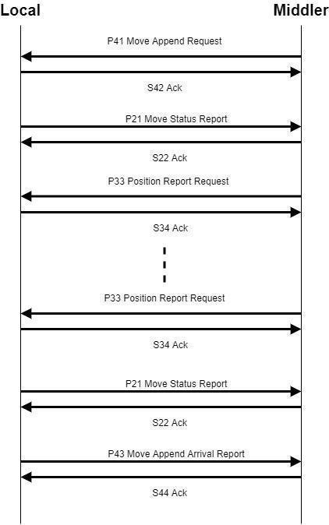
- Load/Unload
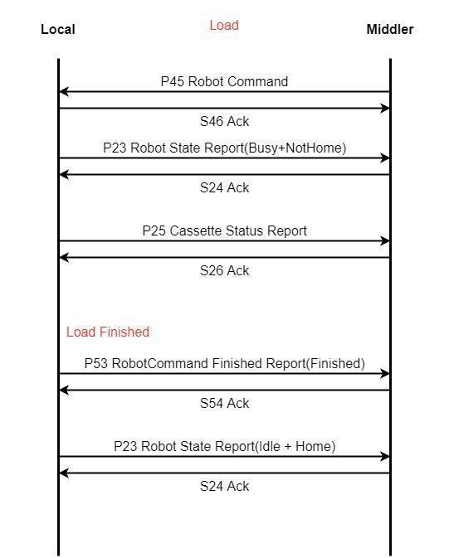
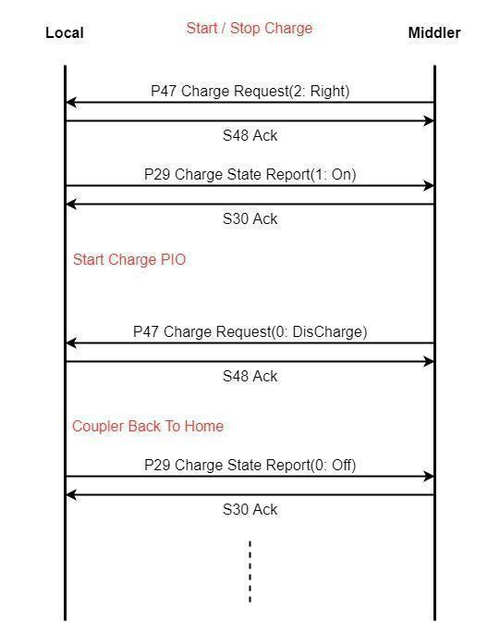
- Abnormal Process Scenario
